The UNHP Northwest Bronx Resource Center (NWBRC) is committed to bringing needed resources to our Bronx community. That commitment is renewed as we face this ongoing COVID-19 crisis. We know people need information about health, food, financial and housing resources at this time. UNHP is answering our phones M-F 9 am until 5 pm at (718) 933-2539. UNHP is offering our free housing and financial services by phone, email, and through our YouTube series, Hard Times Smart Money. Para leer este documento en español por favor clic aqui. Below are city and nonprofit resources available to the public that will be updated as new information comes to light.
The NWBRC also issues newsletters in English and Spanish with important news for Bronx residents. View our latest newsletter here https://unhp.org/publications/newsletters and subscribe here https://unhp.org/projects/northwest-bronx-resource-center to receive our newsletter in your inbox.

HEALTH
New York State (NYS) is on PAUSE and moving through different phases to combat the CoronaVirus. Information here
The Center for Disease Control (CDC) has information about what to do if you are sick on their website.
If you or someone you know needs to quarantine, you may qualify to self-isolate in a hotel, free of charge, for up to 14 days if you do not have a safe place to self-isolate. This can mean:
- Your home does not have space for you to stay six feet away from others
- You share rooms or a bathroom
- You live with someone who is vulnerable
Hotel rooms are also available for New Yorkers without COVID-19 but who live with someone who has COVID-19.
You can call 311 or 844-NYC-4NYC (1-844-692-4692) between the hours of 9 a.m. and 9 p.m and a medical provider will assess your situation and then refer you to a hotel if appropriate.

The Vaccine
Eligibility for the vaccine is being expanded quickly. You can check your eligibility and if you are included in those categories here.
Here is a flier answering some common questions and acknowledging some concerns regarding the vaccine.
Haga clic aquí para ver el documento con los detalles que usted deberías saber sobre las vacunas contra el COVID-19.
If you meet any of the criteria and would like to be vaccinated, you can find a location near you.
You can use this tool to determine eligibility and to schedule an appointment at a New York State-run vaccination site. If eligible, you will see all available appointments at New York State-run vaccination sites.
Yankee Stadium and Javits Center just opened up overnight appointments. Yankee stadium is for Bronx residents only! The Yankee Stadium site is open to eligible Bronx residents. To schedule a visit, call 833-SOMOS-NY or visit somosvaccinations.com. This number can help the Bronx and upper Manhattan residents access the vaccine locally: (646) 838-0319.
New Yorkers who wish to get a vaccine at the Javits Center can schedule an appointment online at the state’s “Am I Eligible?” website, am-i-eligible.covid19vaccine.health.ny.gov, or by calling 833-NYS-4-VAX.
New York City is providing in-home Covid-19 vaccinations (Johnson & Johnson) to eligible NYC residents who are fully homebound, have not already been vaccinated, and do not already have access to a vaccination program. Fill out this form for a call back to further discuss eligibility for the program.
https://forms.cityofnewyork.us/f/homebound
This link compiles vaccination sites and appointments: http://www.nycvaccinelist.com/

Testing
An updated list of Bronx and NYC testing sites can be found at this link.
NYC has an updated COVID-19 portal with information on free testing and other resources: COVID 19 Citywide Portal
Sites are subject to be changed or new locations may be coming in the near future. Text COVID to 692-692 to get regular updates or text COVIDESP to 692-692 for updates in Spanish.
Wellness Resources
During these uncertain times, it’s important to maintain your emotional and mental well being. Below are some resources to safeguard your mental health.
- NYC Well - Talk, Text or Chat - free mental health resources
- Headspace, a company specializing in meditation and sleep wellness, has free resources for coping with the COVID-19 pandemic.
- NEW YORK PSYCHOTHERAPY AND COUNSELING CENTER offers therapy sessions by phone at this time.
- New Yorkers can call the COVID-19 Emotional Support Hotline at 1-844-863-9314 for mental health counseling.
- Senior Citizens call 212-Aging-Nyc (212-244-6469) and ask about the Friendly Visiting Program.

FINANCES
Due to the COVID-19 pandemic, the UNHP Free Tax Prep program has been canceled. We know this is a hardship for the many people who count on us, but we are committed to sharing resources for free and low-cost tax preparation options. UNHP will continue to provide you with helpful tax information, including things specific to 2020 taxes such as the stimulus payment and unemployment.
Free Tax Resources
The 2021 deadline for filing taxes has been delayed to May 17 due to changes that were made to the filing of unemployment benefits and other credits linked to the American Rescue Plan. Click here to read UNHP’s blog about American Rescue Plan benefits and changes. Here you can find links to free tax resources being offered:
- BronxWorks Free Tax Preparation has drop-off and in-person services and is available for single filers with incomes up to $48,000 and filers with dependents with incomes up to$68,000 in 2020. Make an appointment here or call 347-862-9843.
- NMIC has VITA services for single filers with incomes up to $48,000 and filers with dependents with incomes up to $68,000. Make a virtual appointment on their website here or call 929-415-8745 Mondays to Wednesdays 11 am to 7pm and Saturdays andSundays 9 am to 5 pm.
- NYC Free Tax Prep is available for single filers with incomes up to $48,000 and filers with dependents with incomes up to $68,000. At an NYC Free Tax Prep site for drop-off service, you can drop off your tax documents and pick up the completed return later. Open this map to find your nearest site. NYC Free Tax Prep also offers virtual tax prep, assisted self-preparation, and in person tax prep. Call 311 or visit their website to make an appointment.
- Senior Citizens with only social security as income or those who are on public assistance or SSD are eligible for the NYC school tax credit if you were a NYC resident for at least 6 months. Here is a link to print out the school credit tax form and instructions. You can read about other options and requirements here.
- For those that are computer savvy, UNHP can provide a link for Facilitated Self-Assisted Tax Prep (FSA). The FSA link is a free self-file option for any income range. Reach out to UNHP by email at taxes@unhp.org for information and the link to file.
- IRS Free File allows you to do your taxes online for free using one of the Free File partner offers and is available to those with an income under $72,000. Browse all offers here and on the NYS Tax site here. A free e-file checklist can be found here.
You may claim the Earned Income Tax Credit Relief (EITC) if your income is low to moderate. The amount of your credit may change if you have children, dependents, are disabled or meet other criteria. Read the qualification details here.
Remember if you do not owe taxes you can wait until next year to file without penalty. If you did not owe taxes last year and your income and filing statuses are more or less the same this year, you can file anytime during the year or together with your 2021 taxes at another free site or with us in the future. For those that are not required to file and receive a small refund ($63) you may want to wait until next year when you will receive the back payment. You can file up to three years at one time.

Unemployment
The federal government has extended the federal unemployment benefit programs available through the CARES Act for an additional 11 weeks. Pandemic Unemployment Assistance (PUA) and Pandemic Emergency Unemployment Compensation (PEUC) will be available through March 14, 2021, with qualified claimants’ benefits fully phasing out by April 11, 2021. Federal Pandemic Unemployment Compensation (FPUC) benefits will resume with $300 weekly payments until March 14, 2021. For more information, see the Continued Assistance Act FAQs. The American Rescue Plan has extended the deadline through September 6, 2021. Unfortunately, there may be a gap in payments as agencies program these new benefits.
Information about applying for unemployment benefits can be found on the NY State Department of Labor website. This link to the NYC 311 website also has good information about assistance available to unemployed individuals.
IMPORTANT: This relief package made the first $10,200 of 2020 Federal unemployment benefits tax-free for people with incomes of less than $150,000. Up until now, unemployment benefits were considered taxable income by the federal government, so if you received unemployment your taxes will be lowered by this change.
There is still confusion about how this will affect taxes that have already been filed. People who already filed, might have to file an amended return but are urged to wait for guidance from the IRS. If you haven’t filed yet, you should still file your 2020 tax return by the revised May 17 deadline. This blog will be updated with new information as will the IRS website. It is unclear if New York State will also exempt unemployment benefits. To determine if your unemployment is taxable at the State level check this site Are Payments I Receive for Being Unemployed Taxable?
If you received unemployment compensation, you:
- May be required to make quarterly estimated tax payments, or
- Can choose to have federal income tax withheld from your unemployment compensation. Refer to Form W-4V, Voluntary Withholding Request and Tax Withholding.
Unemployment insurance is taxable income on a federal level above $10,200 for certain earners. If you received unemployment this year, you will need form 1099-G from your state’s unemployment office to file for taxes which can be found here. You must be proactive and obtain this—it won’t be automatically mailed to you. The document will be available to view and print on the Department of Labor’s website and will only be mailed to you by request.
If you didn’t choose voluntary withholding, you may get an unexpected tax bill or reduced tax refund. To avoid owing taxes when you file your tax return next year, consider having tax withheld from these payments. Review your records and adjust your tax withholdings by logging in to www.labor.ny.gov/signin, clicking “Unemployment Benefits,” going to “Payment and Tax Withholding Options,” and following the instructions under “Tax Withholding.” Learn more here.
Economic Stimulus Checks
The second round of stimulus payments are $600 for individuals ($75,000 income limit) and $1,200 for married couples ($150,000 income limit) plus $600 for each dependent under 17. No action is required for most recipients. You can check the status of your payment here. If you did not receive a first or second stimulus payment and think you are eligible, claim the Recovery Rebate Credit on your 2020 Form 1040 or 1040-SR. Learn more on the IRS website or on the Consumer Finance Protection Bureau website which can be viewed in Spanish and other languages. New this time: The second round of stimulus is retroactive to the mixed-status families where at least one household member has an SSN. These families will receive checks for $1,200 per household and $500 per child as previously allocated by the CARES Act. This retroactive payment can be claimed through the Recovery Rebate Credit when filing taxes.
The Third Round of Stimulus relief package will provide a $1,400 per person stimulus direct deposit, check, or debit card (depending on how you received your last tax return) to households with adjusted gross incomes of $75,000, $112,500, and $150,000 or below for single filers, heads of households, and married couples filing jointly, respectively. This third stimulus payment will include adult dependents, such as college students or older relatives, unlike the first two. To be eligible for this payment, you must have a social security number.
Your 2020 income will determine your eligibility for these payments if you have already submitted your 2020 taxes. If you have not done your taxes yet, the eligibility will be based on your 2019 income. Even though Free Tax Prep sites are limited this year due to Covid-19, UNHP recommends seeking out free tax prep by using our guide or calling 311 to locate in-person, drop-off, virtual, and self-assisted sites. Check out UNHP’s Free Tax Prep Guide to find options for self-assisted, drop-off, in-person, and drop-off tax preparation.

You can check on the status of your stimulus payment through this website or by calling 800-919-9835. If you did not receive the first two payments but qualify, you can claim them on your 2020 taxes through a recovery rebate credit. If your income is newly eligible for a stimulus payment, you can either file your 2020 taxes soon or reclaim the payment in your 2021 taxes.
Financial Coaching: Working with a trained professional who collaborates with and guides their clients to reach their financial goals. The process is personalized and non-judgmental and financial coaches provide support, encouragement, accountability, and tools to help people make informed decisions.
UNHP and its partners at Neighborhood Trust Financial Partners and Ariva are offering free remote financial coaching to help all New Yorker’s stabilize their finances and move towards financial growth.
- NTFP offers counseling via TrustPlus—a tele-coaching service designed to provide financial coaching via phone or Skype. More information on the UNHP website and on the Neighborhood Trust website.
- Ariva, UNHP’s sponsoring agency for its tax program, is also offering free financial coaching remotely. Call UNHP to arrange free financial coaching or call them at (718)292-2983, visit Ariva’s website here or connect with them through NYC Financial Empowerment Centers now offering phone appointments.
UNHP’s Financial Education Mini-Video and Chat Series: Hard Times Smart Money
Short, smart financial education videos are available in English or Spanish on UNHP’s Youtube Channel: UNHP83 You can subscribe to our channel ( all free of course!) to get notifications as new videos are aired. Use this form to sign up to chat your questions and experiences with UNHP trained staff.
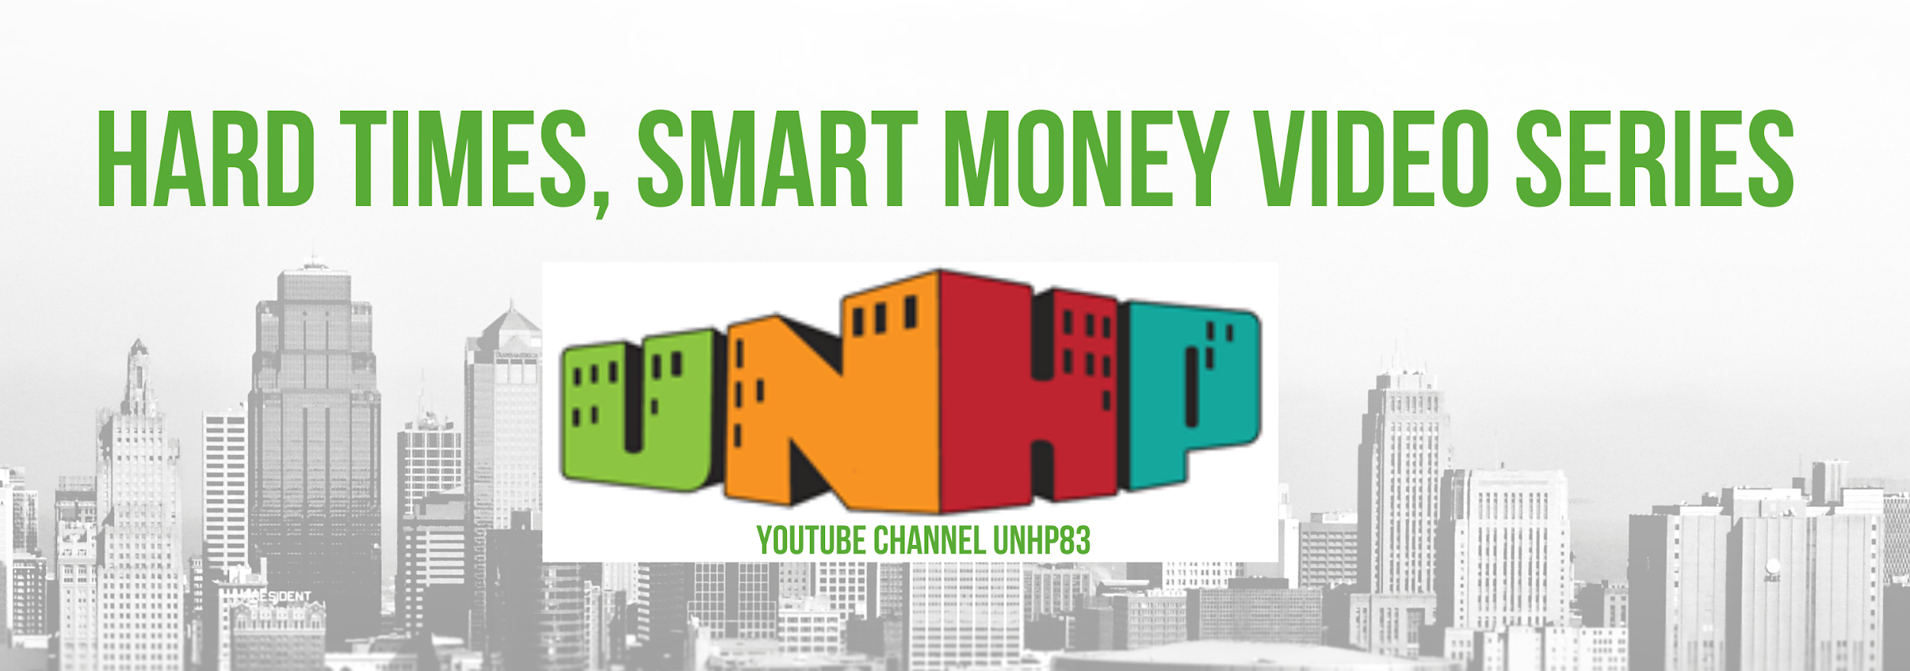UNHP’s Mini Financial Education Series: Hard Times Smart Money can be found on our Youtube Channel. Short smart videos to help you during these challenging financial times. Videos available in English and Spanish. Chat groups available as well!
Other Financial Resource Guides
- NYC has an up-to-date portal for all COVID19 resources.
- NYC has added a resource guide for businesses and the community by zip code in multiple languages here
- The Consumer Finance Protection Bureau (CFPB) works to promote fairness and transparency for mortgages, credit cards, and other consumer financial products and services. Their website located here - has clear, and up-to-date information about COVID 19 resources, taxes, economic stimulus, and consumer scams.
- Neighborhood Trust Financial Partners has compiled a comprehensive guide for NYC resources during this pandemic. Visit the guide here.
- Community Service Society provides useful financial tips on their website.
- From Aid to Z: The Basics on COVID-19 Assistance for Renters, Homeowners & Businesses By City Limits
- Immigrant Resources and Information in Spanish from the Coalition for Humane Immigrant Rights
- Gray Panthers & Florence Belsky Charitable Foundation proudly present a carefully curated set of resources for NYC seniors and volunteer opportunities for those who love them during this COVID-19 crisis.
- Services for the Underserved compiled a list of resources for those caring for and working with people with developmental disabilities.
- Office of the NYS Comptroller- COVID Financial Survival Toolkit
- Phipps Neighborhoods Resources for New Yorkers
- National Community Reinvestment Coalition Covid-19 Resource guide

HOUSING
A safe and affordable home is even more important now during the Covid-19 crisis. Remaining housed in your apartment or the home you own is also crucial. NY has many resources for struggling tenants and homeowners including eviction prevention, foreclosure prevention, the affordable housing lottery, the NYC Rent Freeze for seniors and the disabled and the use of 311 to report apartment conditions.
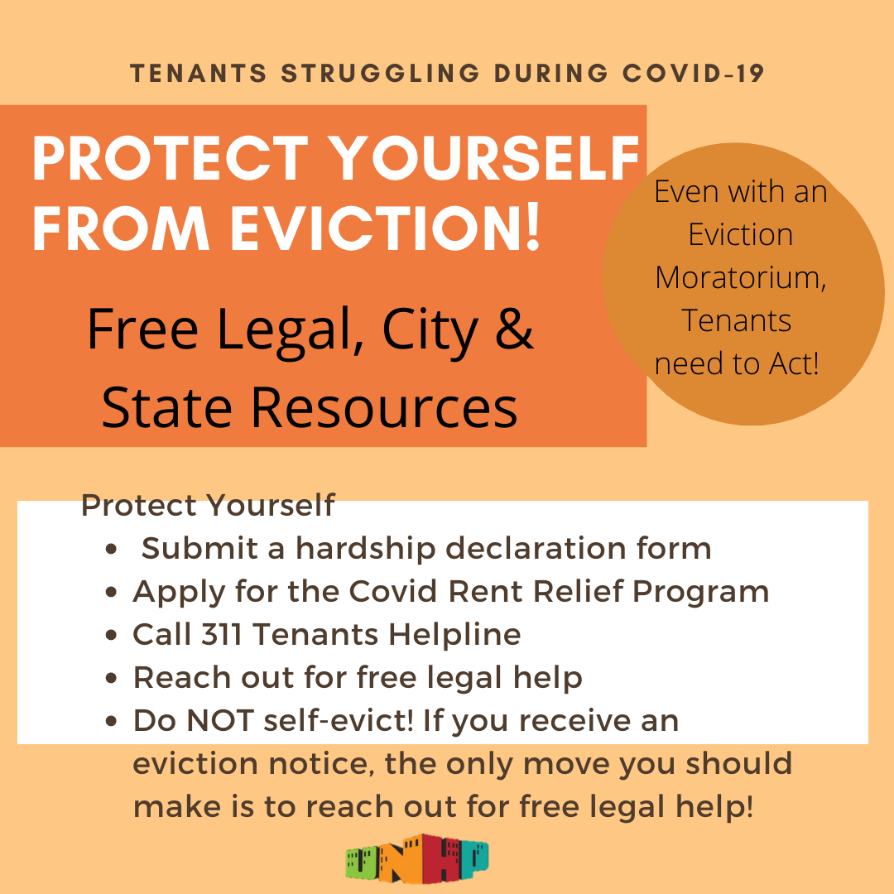
Eviction Prevention
Recently, the federal eviction moratorium has been extended to January 31st, 2021. The moratorium protects tenants from evictions due to nonpayment but tenants must provide their landlord with a sworn declaration stating: that they have sought government assistance, make less than $99,000 ($198,000 for joint filers), have suffered a loss in income, and that they would become homeless or have to double up if evicted. The COVID-19 Emergency Eviction and Foreclosure Prevention Act also offers a two-month moratorium of residential evictions and can be extended to May 1st if tenants fill out a declaration of hardship found here or here in Spanish. The Act does not restrict COVID-related hardship to loss of income but also extends protections to households with members who are especially susceptible to severe illness from COVID-19.
A portal with information and resources for NYC tenants impacted by covid-19 can be found here.
FHEPS is a rent supplement for families with children who receive Cash Assistance and have been evicted or are facing eviction, who lost their housing due to a domestic violence situation, or who have lost their housing because of health or safety issues. An application can be found here if you believe you may qualify.
UNHP created a blog post with information and links for Eviction Prevention. Even though there is an eviction moratorium it is crucial that struggling tenants protect themselves against eviction after the moratorium is lifted.The NYS Covid Rent Relief program closed on 2/1/21, but tenants can file a hardship declaration, call the 311 tenants helpline, get free legal help if necessary, know their rights and don’t self-evict. Links to do these recommendations are on the blog post.
Help for Homeowners
The federal CARES Act provides forbearances (temporary payment suspension) for homeowners with federally-backed mortgages. You can look up whether your mortgage is federally-backed and covered by the CARES Act on the CFPB website.
Under both state and federal law, if you are experiencing financial hardship due to COVID-19, you have the right to request a 180-day forbearance and if eligible, you can then receive a forbearance, during which you do not need to make payments. At the end of the forbearance, if you are still experiencing financial hardship, you can request an additional 180-day forbearance. You must contact your servicer to receive relief. During your forbearance, additional interest will not accrue on the forborne payments—there will be no “interest on interest." Additionally, your servicer may not charge you a fee or penalty for requesting or receiving a forbearance.
You’ll find their contact information on your most recent bill. Each servicer will have different application procedures for relief, which will involve different standards and criteria.
Housing counselors that handle foreclosure-related issues can give you advice on your options and resources at little or no cost. Housing counseling resources for New Yorkers include:
- UNHP partners with The Legal Aid Society. Their Bronx Homeowner Foreclosure Prevention Unit can help homeowners understand their options and provide free assistance and legal advice at (646) 340-1908.
- New York’s Homeowner Protection Program (HOPP), which connects with housing counselors and legal services at no cost. Call the HOPP hotline at (855) 466-3456 or visit https://homeownerhelpny.org/
- You can find a list of approved non-profit housing counselors by county here, on the DFS website.
- 24-Hour assistance is available toll-free on the HOPE NOW hotline at 888-995-HOPE (888-995-4673).
- You can also call 311.
Affordable Housing Lottery
NYC HPD created a new version of Housing Connect called Housing Connect 2.0 in July 2020. There are no longer any affordable housing opportunities available on the original NYC Housing Connect website but you can still visit the original website to check your log number for a previously submitted application. If you previously had a housing connect you must create a NEW profile and use the Housing Connect 2.0 program. Otherwise, for new applicants, here is the link to the Housing Connect site and you can create your new profile there and click on the learn tab for informational videos.
Housing Connect
Housing Connect is the NYC online affordable housing lottery. Lotteries are open at this time.
NYC HPD created a new version of Housing Connect called Housing Connect 2.0 in July 2020. There are no longer any affordable housing opportunities available on the original NYC Housing Connect website but you can still visit the original website to check your log number for a previously submitted application. If you previously had a housing connect you must create a NEW profile and use the Housing Connect 2.0 program. Otherwise, for new applicants, here is the link to the Housing Connect site and you can create your new profile there.

How to: Housing Connect
This link provide access to short videos on how to create a Housing Connect account and apply for lotteries: https://housingconnect.nyc.gov/PublicWeb/about-us/training
- For UNHP program users with existing accounts: call UNHP at (718) 933-2539 to apply for new lotteries, update your information or ask a question. UNHP can also connect you to a Financial Counselor to address credit and budget issues that may affect your housing application.
- For users without accounts: UNHP is currently unable to hold face-to-face appointments to create Housing Connect accounts. Clients that feel comfortable with computers can create their own accounts at home. Call UNHP if you have questions about creating an account on your personal computer. This video explains how to create an account on your own. Remember you can also request an application by mail if necessary.
NYS Affordable Housing Lotteries
NYS Housing and Community Renewal also has a multifamily affordable housing lottery with properties in Westchester County and upstate locations. Information and applications at this link: https://hcr.ny.gov/lotteries
Reporting Housing Conditions
Tenants can report a housing complaint to HPD by calling 311 or using 311 online.
A list of tenant rights and protections can be found here. For rent regulated tenants, protections have been outlined here.
There are many legal organizations that provide free legal help to tenants in NYC, Legal Aid Society, Legal Services, Legal Hand, POTS, to name a few. The NYC Mayor’s Office to Protect Tenants has a list of the phone numbers for eviction prevention resources. UNHP suggests calling the 311 Tenants helpline first so a counselor can understand your case and provide you with the correct next step or referral. Here is another legal referral list. If many tenants in your building are facing similar issues such as harassment, poor building conditions, lack of services and rent overcharges you may want to work with an organizing group to join with your neighbors to fight for improvements. In the Bronx Northwest Bronx Community and Clergy Coalition and CASA do organizing work. JustFixNYC has tools for tenants and a list of other organizing groups under partners on their website. Organizing works!
Here are some useful links for tenants struggling to keep up with rent payments during this time:
- NYC Tenant Support Unit
- One-Shot Deal Application
- HRA Legal Assistance
Other Housing Programs
For updated information call 311 or Visit The Mayor’s Office to Protect Tenants at this link: https://www1.nyc.gov/content/tenantprotection/pages/covid19-home-quarantine
UNHP can connect you with a bilingual Tenant Support Specialist to assist with landlord harassment, overcharge issues and eviction prevention. Call UNHP at (718)933-2539 to arrange a phone session. POTS is offering a remote legal clinic. Legal Clinic: Clients seeking assistance may contact the clinic directly to schedule a phone meeting at 718-220-4892×111 or 117. No meetings are being held on-site at this time.

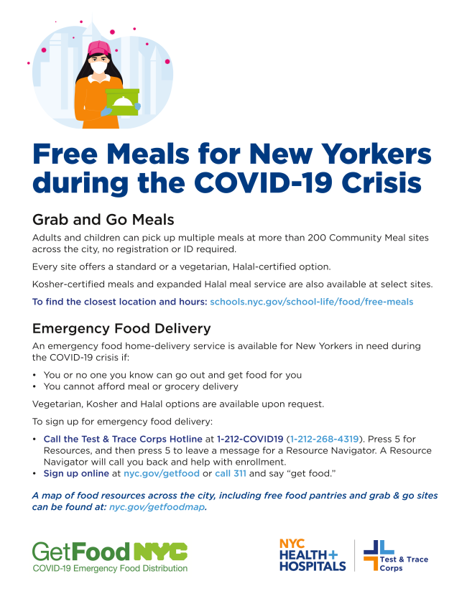
FOOD PICK-UP AND DELIVERY
NYC 311, New York City’s Official Website( or call 311 to access by phone), has a lot of city resources currently listed. The following are specifically for meal delivery and pick-up:
Free meals links:
- Visual Food Map
- Locations and hours
- Food bank for NY
You can also text “NYC FOOD” or “NYC COMIDA” along with your zip code to 877-877 to find a free meals location near you. Standard text messaging rates may apply.
This is the link to the NYC Food Delivery Assistance program. It will outline the restrictions. If you need help filling out this web form call 311 or UNHP at (718) 933-2539.
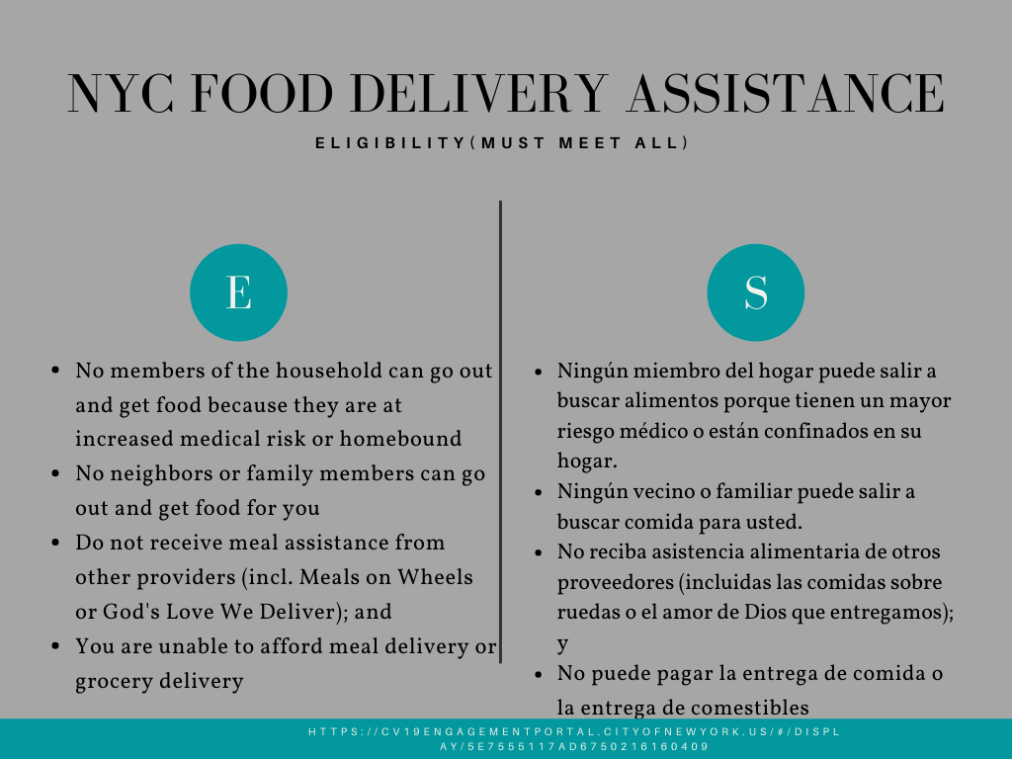
Local Bronx Organizations offering food and other resources
- Part of the Solution (POTS) has a food pantry and meals for pick up as well as other resources such as job help by phone. View those resources here.
- Mosholu Montefiore Community Center also has a food pantry plus other services like childcare and workforce development. View the resources here.

UNHP Northwest Bronx Resource Center
The UNHP Northwest Bronx Resource Center is here to help! We are offering a variety of remote programs to help people remain in their homes and build financial stability. Find them here.
Due to the current health crisis, face to face assistance is no longer available at the Northwest Bronx Resource Center(NWBRC). You can still call us at (718)933-2539. Our phones are being answered remotely by our bilingual staff and trained volunteers.

We can:
- Update your existing NYC Housing Connect account
- Answer questions about the affordable housing lottery
- Give you information on local Bronx resources for meals, food pantry and other essential needs
- Connect you with a trained Financial Counselor to provide counseling over the phone
- Connect you with a Tenant Support Specialist
- Connect homeowners with support from Legal Aid
- Assist Senior Citizens and tenants with disabilities freeze your rent by phone. Call UNHP at (718)933-2539
- Direct you to Free Tax Prep Options ( Our site is closed in 2021)
- Link interested First-time homebuyers with Financial Counseling and Special Programs
Read more about our remote services here and call us if you need help at (718)933-2539.
UNHP will continue to bring the most updated resource information during this pandemic. Call UNHP at (718)933-2539 if you need help. To get the most up-to-date information, check our website, this blog post which will be updated and follow one of our social media pages:(add links here)

